General
This section will provide details about the General features build into the BUG mod. Here is a screenshot of the options screen:
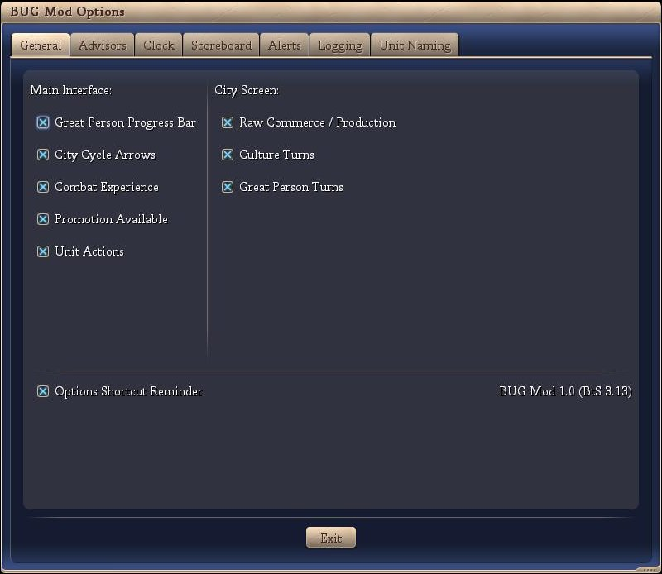

The individual General features are discussed below:
- Main Interface
  - Great Person Progress Bar
If checked, the Great Person Progress Bar is displayed. If the user clicks on the tab, the highlighted city screen is opened. There are three display options as illustrated below.
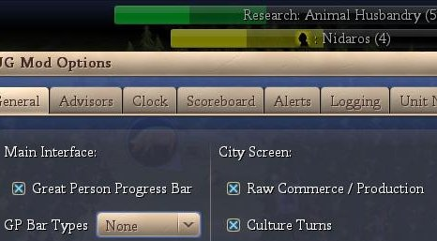
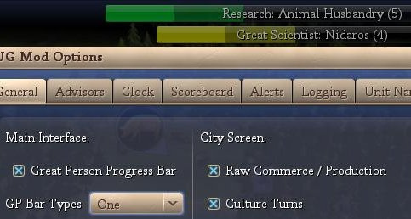
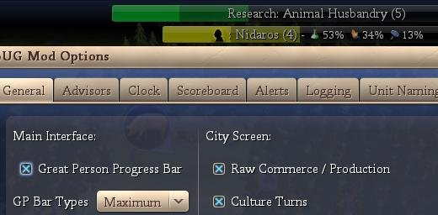
  - City Cycle Arrows
If checked, the City Cycle Arrows are displayed (see below). By clicking on the right / left arrows, the user is taken to the next city in the cycle while in the main interface screen.
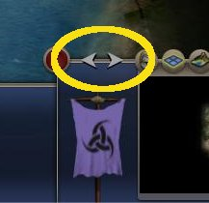
  - Combat Experience
If checked, the Combat Experience counter from the F5 screen is displayed (see below)
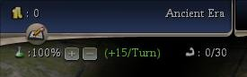
(the strong arm with the 0/30)
  - Promotion Available
If checked, a unit with a promotion available has a light blue highlight around its plot icon (see below).

(the blue highlight around the warrior)
  - Unit Actions
If checked, a unit that has a pre-defined action (heal, goto, automated, fortified, etc) has text describing the action added to the bottom of its plot icon (see below).
(the ‘FORT’ on the archer signifying fortified and the ‘SKIP’ on the workers signifying that I have skipped those units for this turn).
- City Screen
  - Raw Commerce / Production
If checked, the City Screen shows the city’s raw production or commerce (see below). A button is available so the user can cycle between production or commerce. The source of the production or commerce is also shown.
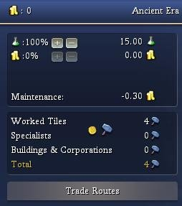
(city production)
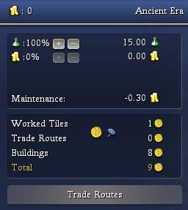
(city commerce)
  - Culture Turns
If checked, the number of turns to the next cultural level is displayed (see below). No turns are displayed if the city is already Legendary or the city is not producing any culture.
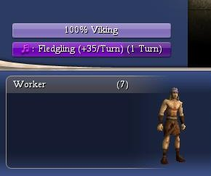
  - Great Person Turns
If checked, the number of turns to the next Great Person is displayed (see below). No turns are displayed if the city or the city is not producing any Great Person points.
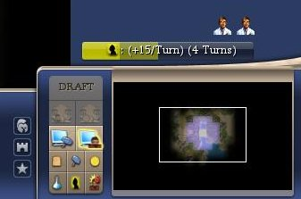
- Options Shortcut Reminder
if checked, the BUG options screen short cut is displayed (see below).
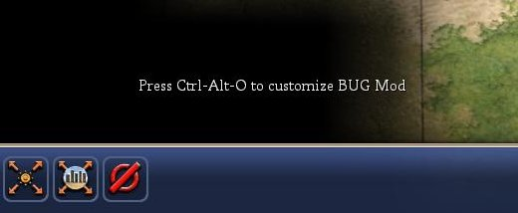

Conclusion
Opinion: It is our opinion that no additional information is presented to the user via this section of the BUG mod and it should be approved.

